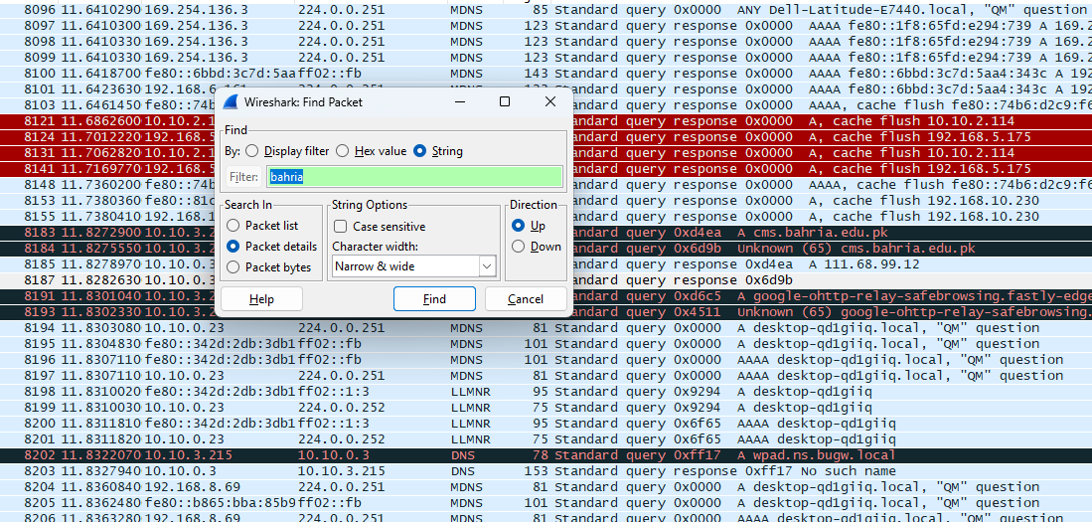

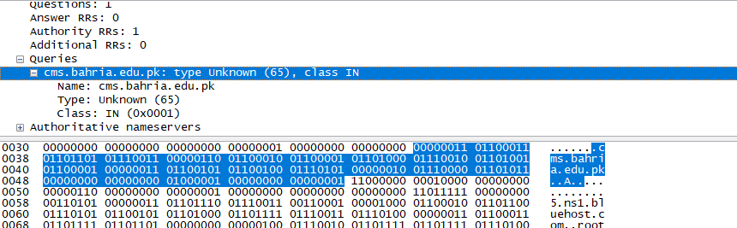

Ethernet is the MAC Address

|  |  |
| --- | --- |
| YOUR PC IP ADDRESS | 192.168.56.1 |
| Your PC MAC Address | 50-81-40-7A-DA-39 |
| Default Gateway | 10.10.0.01 |
| Website Access | CMS |
| Website IP Address | 111.68.99.12 |
|  |  |

|  |  |  |
| --- | --- | --- |
| P  arameter Name | Field Value | Field Length |
| Source MAC address | 9c:b6:54:03:el:6a | 48 |
| Destination MAC address | 50:81:40:7a:da:39 | 48 |
| Destination TCP Port | domain(53) | 16 |
| Source TCP Port | 52466(52466) | 16 |
| Website DNS address | Cms.bahria.edu.pk | 152 |

MAC = ETHERNET

Tcp = Datagram